Engaged@Way-of-Work Survey  
Findings & Recommendations

for

[CLIENT NAME]  
[Client physical address]



**Prepared by:** [NAME]

[NAME]

**Date:** [DATE]

Table of Contents

Executive Summary i

1 Background i

2 Summary of Survey Results i

3 Findings & Observations i

4 Recommendations i

5 Suggested Next Steps i

Survey Findings & Recommendations 1

1 Background 1

2 Organisational Profile & Context 1

3 Survey Design & Metrics 1

4 Summary of Survey Results 2

5 Employee Engagement 7

6 High Level Themes Observed 11

7 Recommendations to turn Feedback into Action 12

8 Proposed Engagement Plan 13

9 Summary 15

Appendix A: Engaged@Way-of-Work Methodology & Approach i

1 Theoretical Context i

2 Organisational Development Principles i

3 The Process of Interpretation ii

4 Engaged@Way-of-Work Survey Dimensions & Constructs ii

Executive Summary

# Background

# Summary of Survey Results

* Employee engagement...
* The strengths approach...
* Flow in the workplace...

# Findings & Observations

* Theme #1: Xxxxx......
* Etc.

# Recommendations

* Intervention #1...
* Etc.

# Suggested Next Steps

The following steps are proposed to drive engagement within the organisation:

* Step #1...

Survey Findings & Recommendations

# Background

[Describe shortly the background regarding the project – what gave rise to it, who initiated it, what problem does it have to address. This can in most cases be copied from the proposal.]

[The survey results of the demo survey Acme Corporation have been used to illustrate certain concept in the remainder of this document]

# Organisational Profile & Context

[Summarise the client’s organisational background and strategic context based on information gleaned from the initial sponsor context meeting (see *3.2 Guidelines for Conducting the Sponsor Meeting: Context & Expectations* in the *Engaged@Way-of-Work Survey Findings & Recommendations Method* document)]

# Survey Design & Metrics

[Briefly summarise the survey numbers – dates of the survey, how many responses from how many total, overall confidence level and sampling error, etc.]

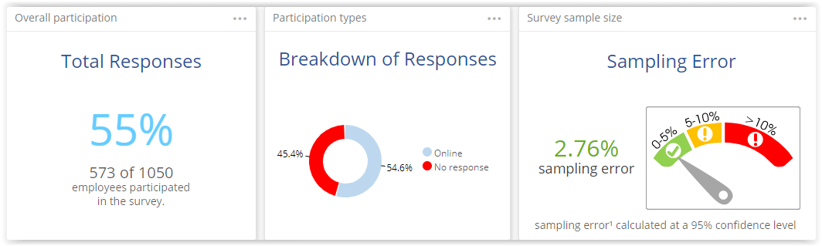

[Insert the departmental participation statistics (below) from the Organisation Overall survey report]

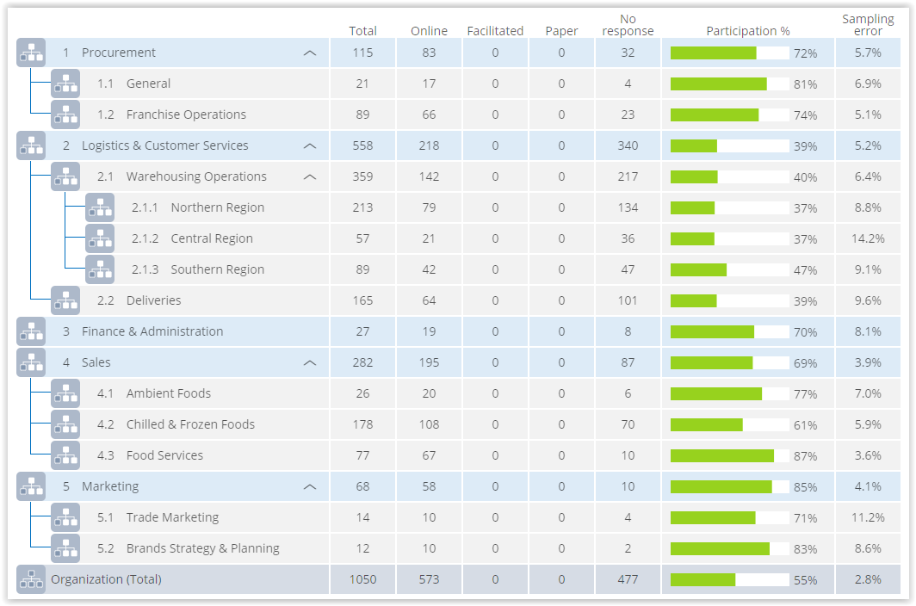

# Summary of Survey Results

## Overall Survey Results per Survey Dimension

[This involves only a short, convenient 1-page summary of the survey results (no analysis or interpretation), exactly the same as in *2. Summary of Survey Results* in the *Executive Summary.* Briefly summarise the overall survey data for each dimension (engagement, strengths, flow) and include a diagram/graph where possible. Below an example from the ClientName report:

EXAMPLE: The summary of the survey results is based upon ClientName’s overall scores for indicators of the different Engaged@Way-of-Work dimensions. The scores are summarised in the graph below. Explain implications of Commitment, Willingness and Retention scores.]

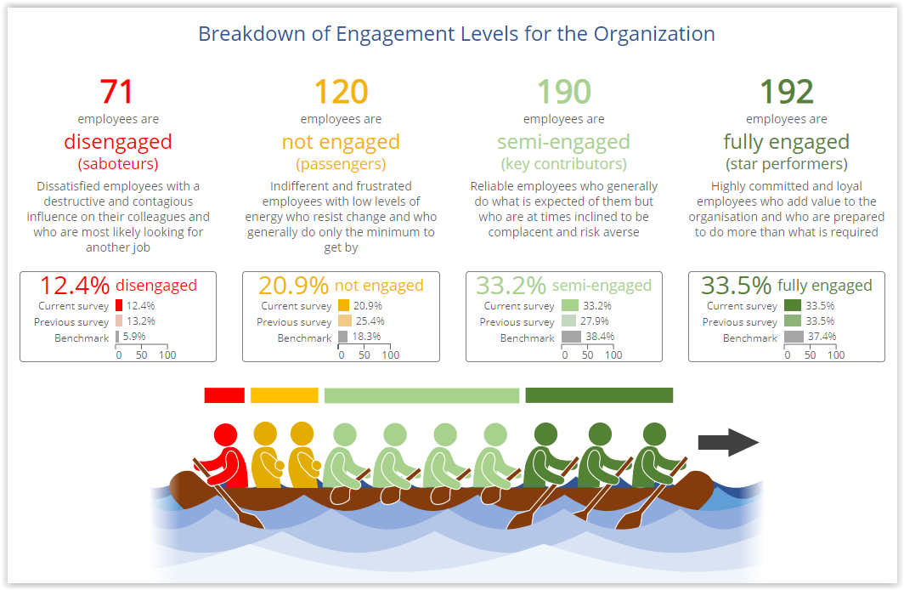

ClientName’s employee Fully Engaged level is currently reported at 33.5%, which is slightly below the benchmark of 37.4%.

## Engagement Levels per Department

This section has two parts:

(1) Overview and discussion of the engagement levels of all the departments and any significant trends and noticeable titbits. List the FACTS and DEDUCTIONS separately. Include a heatmap table that summarises the engagement levels of the different department – see example below:

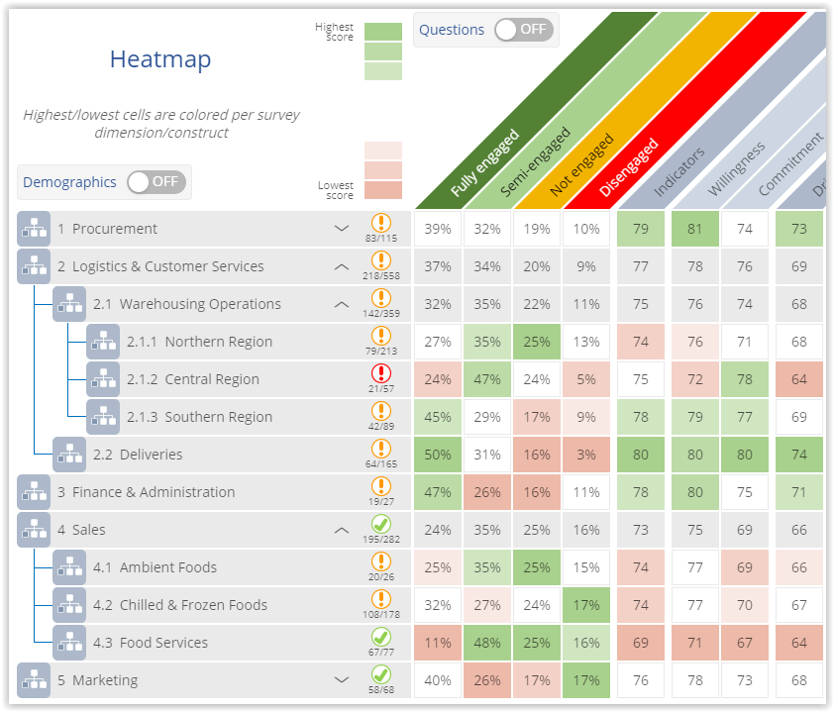

(2) Identify and discuss comparable high and low scoring departments – the reasons for the choices and some of the more significant differences. Illustrate the differences by means of the Comparison tab in the dashboard – see example below with lowest scoring division/department (Food Services) vs highest scoring division/department (Deliveries):

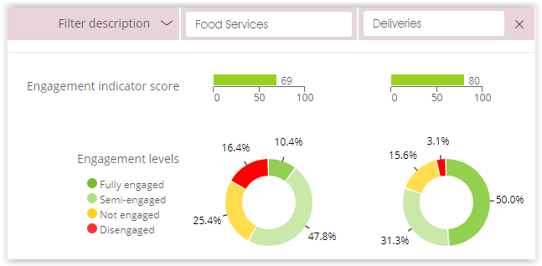

If possible try to introduce appreciative inquiry principles here. Mention that these two departments will be used throughout the report to illustrate certain points and issues.

## Engagement Levels per Demographic

[Review the demographic data for all the engagement indicators, and list the FACTS and DEDUCTIONS separately. Use graphs to illustrate a point, e.g. according to the graph below it seems that males are less engaged than females in a particular business unit.]

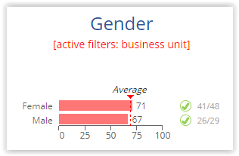

[Or Senior Managers are less engaged than their operational staff. Answer the WHY or SO WHAT questions to make the deductions.]

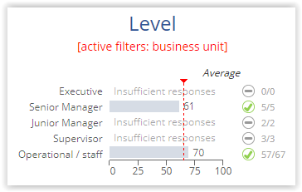

## Top & Bottom Scoring Survey Questions

### Top Five Highest Ranked Survey Questions

[List and discuss the FACTS and DEDUCTIONS of the top scoring survey questions, and include the graphic – see example below.]

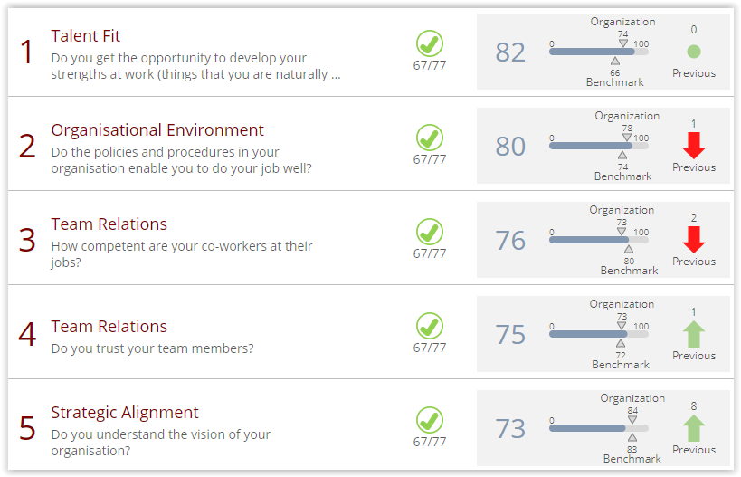

### Bottom Five Lowest Ranked Survey Questions

[Same for the bottom scoring questions – clearly the business unit whose data is show below have a problem with growth opportunities and a serious leadership trust/role model problem – state some FACTS and make some DEDUCTIONS]

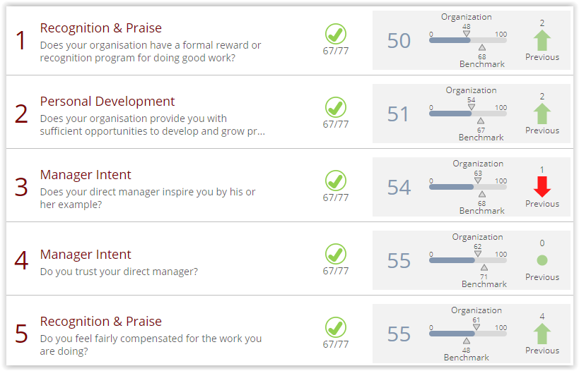

# Employee Engagement

## Engagement Level

[Discuss organisation’s overall engagement levels and:

* why and how the current engagement level impacts the organisation,
* the opportunity that exists for converting not-engaged employees to engaged, and
* the negative impact of disengaged workers.

Include the organisation’s overall engagement graphs]

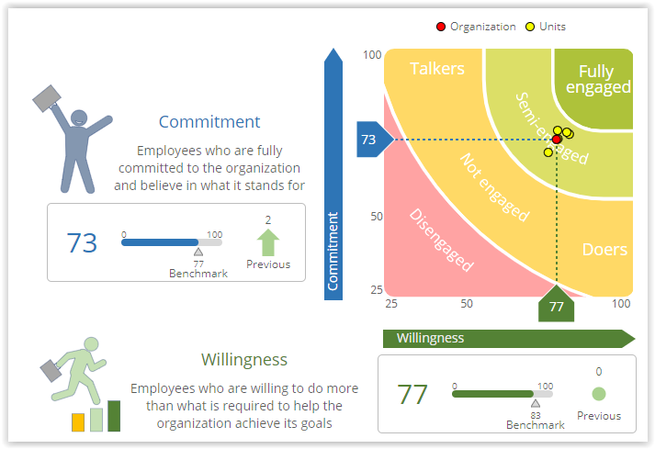

## Employee Engagement Indicators

### Commitment to the Organisation and its Values

[Discuss FACTS and DEDUCTIONS re the Commitment indicator of engagement. Both positive and negative issues should be discussed where appropriate. An example of the bullet point text for the DRAFT report is show below:

* Facts:
* POSITIVE: 80% believe in organisation and what it stands for
* NEGATIVE: 24% would not recommend organisation as a great place to work
* NEGATIVE: 33% do not see themselves working for organisation a year from   
  now
* Deductions (WHY/SO WHAT?):
* WHY: Despite strong support for mission of organisation, work conditions (safety and security) and favouritism contribute to negative perception of organisation
* SO WHAT: Negative impact on talent retention

An example of the above Facts and Deductions rewritten into full sentences for the FINAL report is shown below:

Responses to the individual survey question highlight a contradiction though. Although 80% of the respondents indicated that they believe in the organisation and what it stands for, a significant 24% indicated that they would not recommend the organisation as a great place to work, and 33% indicated that they might not see themselves working for the organisation a year from now. This could indicate that despite an overwhelming support for the mission of the organisation, other factors such as work conditions (safety and security) and favouritism could contribute towards a negative perception of the organisation by a significant number of employees. This could have a direct impact on employee engagement in general and talent retention in particular. ]

### Willingness to Invest Additional Effort

[Discuss FACTS and DEDUCTIONS re the Willingness indicator of engagement.]

## Drivers of Engagement

[General discussion re the engagement drivers. Include a graph – see example below.]

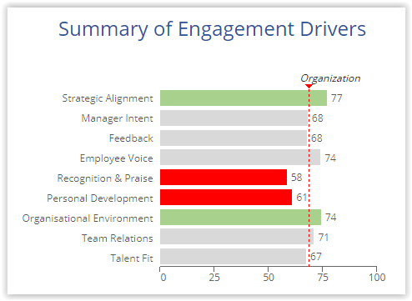

### Strategic Alignment

[Discuss FACTS and DEDUCTIONS re the driver. Drill down into the Driver’s individual survey questions and use the outliers to justify appropriate deductions, e.g.

The overall score for the driver is 3.1, with 75% of employees feeling that they have a clear understanding of how important their jobs are to the organisation’s success. However, due to the differences observed in scores pertaining to this dimension across the departments, it is evident that even though 87% of the employees feel that their job roles do help to achieve corporate goals, the perception exists that the organisation does not have clear performance goals and that employees are not provided with adequate feedback regarding organisational progress towards achieving set objectives. In addition, 44% of employees were not sure how their department or section’s performance gets measured. This could suggest that performance goals are not adequately cascaded down to lower levels of the organisation and that performance are not measured and monitored on a regular and consistent basis. ]

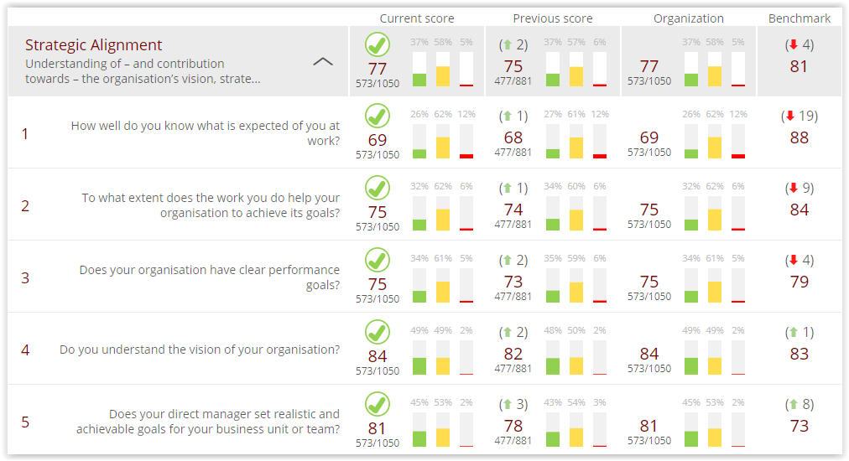

### Manager Intent

[Do the same for the rest of the Drivers]

### Etc.

# High Level Themes Observed

[Note: the DEDUCTIONS from the previous section of the report should be combined and grouped into common Themes]

The review and analysis of the survey data have highlighted a number of themes that need to be addressed.

## Observed Theme #1: Xxxx

### Survey Evidence

[Summary of DEDUCTIONS for this specific theme.]

### Recommended Interventions

[Brief description of the different recommended remedies (Interventions A, B etc.) for this theme.]

## Observed Theme #2: Xxxx

Etc.

# Recommendations to turn Feedback into Action

[Note: the Interventions for the different Themes should now be summarised and Activities for each Intervention should be devised]

The following interventions are proposed as a means to equip the organisation with the capabilities to improve the general level of engagement.

|  |  |  |
| --- | --- | --- |
| #1 | Intervention A | * Activity#1 * Activity#2 * Etc. |
| #2 | Intervention B | * Activity#1 * Activity#2 * Etc. |
| #3 | Etc. |  |

# Proposed Engagement Plan

A phased approach that prioritises the interventions with respect to (1) their impact on the organisation’s success as well as (2) quick wins that will help to build the required momentum is proposed. All interventions will focus on activities that build engagement at an organisational, team and individual level. The engagement action plan as outlined on the next page will have to be work shopped and refined with the involvement of all the [client name] role players in order to identify necessary roles and responsibilities.

|  |  |  |  |  |  |
| --- | --- | --- | --- | --- | --- |
| Engagement Action Plan | | | | | |
| Area of Focus | Priority | Phase 1 | Phase 2 | Phase 3 | Phase 4 |
|  |  |  |  |  |  |
|  |  |  |  |  |  |
|  |  |  |  |  |  |
|  |  |  |  |  |  |
|  |  |  |  |  |  |
|  |  |  |  |  |  |
|  |  |  |  |  |  |
|  |  |  |  |  |  |
|  |  |  |  |  |  |
|  |  |  |  |  |  |

## Quick Wins

[Describe interventions that will have quick short-term results that will help to show the employees that management is serious about doing something about the survey outcomes.]

## Suggested Next Steps

[Summarise the immediate next steps that the client should undertake.]

# Summary

[Short conclusion paragraph. C’mon, surprise us!]

Appendix A:  
Engaged@Way-of-Work Methodology & Approach

# Theoretical Context

Mindset’s Engaged@Way-of-Work model is based on the results of extensive market research conducted by Gallup, Towers Perrin, BlessingWhite, The Hay Group and others, and builds on the pioneering work of Mihaly Csíkszentmihályi. It maps a path that will help companies and business units create work conditions that will enable people and ideas to flourish, where employees enjoy doing their best, and where they are optimally productive and customer oriented. In short, it provides the context and framework for creating the conditions that will allow employees to be engaged and for performance to flow.

# Organisational Development Principles

Mindset Management Programs adopts a constructivist approach to organisational development which entails the co-creation of understanding with the client as part of the interpretation process. This implies an open systems technique approach that enables the OD practitioner to understand the data within the context of the client organisation. The approach also affords the opportunity to co-construct meaning and significance with the client organisation.

The interpretation of the data was based upon the following OD principles which informed and guided the interpretation process:

## Evidence-based Recommendations

All observations were based on observed evidence that was obtained from the assessment data and interpreted within the context of the current industry trends and the knowledge economy environment.

## Scientifically Researched Constructs of interpretation

The constructs utilised within the assessment approach are based upon scientific research and benchmarked to industry norms and trends.

## Client Validation and Co-construction

Observations as contained in this report are made from outside of the organisational system and are based exclusively on an in–depth analysis and review of the Engaged@Way-of-Work Survey responses and data, without the benefit of context provided by local knowledge or first-hand experience of the client’s operational environment and organisational. All observations will however be validated with the client to inform and enable a better understanding of the significance of the results.

# The Process of Interpretation

The interpretation process entailed the following steps:

* **Step 1:** Analysis of high level and trends viewed in light of the contextual environment and industry norms evident from the research
* **Step 2:** Evaluation of the data with emphasis of the statistically significant areas indicated through the assessments
* **Step 3:** Exploration of the themes of meaning evident within the departmental data.
* **Step 5:** Validation of the observations with industry SME based upon the investigation and analysis.
* **Step 5:** Recommendations made upon the observations of trends and subsequent data
* **Step 6:** Feedback to client

# Engaged@Way-of-Work Survey Dimensions & Constructs

The *Engaged@Way-of-Work Survey* measures the indicators or results (i.e. whether you have a performance or engagement problem at your organisation or not) as well as the factors which drive those results.

## Engaged@Way-of-Work Survey

Mindset’s Engaged@Way-of-Work Survey is an effective instrument that will help to identify the factors which have a sustainable impact on performance levels and overall productivity in the organisation. The survey will help the company to:

* Target engagement interventions by providing insights into the activities and drivers that impact employee engagement and performance at the company. The survey will help to isolate performance problems and will provide a clear picture of what drives talent retention and employee loyalty.
* Set a benchmark that will make it possible to monitor and track over time the impact and progress of any changes or interventions that have been instituted. This will make future targeted interventions much more effective.
* Quantify the benefits by correlating the survey results with other types of business metrics (e.g. production figures, defects, absenteeism or injury statistics). By doing this it should be possible to quantify the competitive and financial gains resulting from any engagement interventions that have been undertaken at the organisation.

To enhance bottom-line profitability, Mindset’s Engaged@Way-of-Work Survey assesses both the Indicators and Drivers of employee engagement:

* Indicators tell you how well you are doing, what the measurable results or outcomes are, e.g. how engaged your employees are;
* Drivers tell you which elements have a direct impact on those results, e.g. the factors that have the greatest impact on the level of employee engagement in your organisation. For example, aspects such as recognition, working conditions or career opportunities are drivers of engagement – they don’t indicate how engaged someone is, but they contribute towards engagement.

The Engaged@Way-of-Work Survey utilises 42 carefully researched survey questions to measure the indicators and drivers of the strengths approach, employee engagement and flow in your organisation. Survey responses are correlated according to individual departments/sections and various demographic parameters to provide an in-depth view of the performance-health of your organisation.

The survey serves as a source of insightful, relevant and actionable information that will make the implementation and tracking of targeted engagement interventions much more effective. It will help you to improve productivity and actively pursue business objectives. It will also enable you to examine the relationship between engagement or strengths-approach interventions and business outcomes, so that competitive and financial gains can be quantified and tracked.

## Indicators of Engagement



**Indicators** measure the **engagement levels** in the organisation

The **engagement levels** are measured with respect to:

(1) the employees' **commitment** to the organisation, its leadership and their jobs *(e.g. would you recommend your organisation to your friends as a great place to work?)*, and

(2) their **willingness** to do more than what is required to help the organisation meet its objectives *(e.g. in your view, how much effort do the employees in your organisation put into their work?)*



Disengaged  
(derailers)

Dissatisfied employees with a destructive influence and who are most likely looking for another job

5%

Not engaged  
(passengers)

Indifferent and frustrated employees with low energy levels who do only the minimum to get by

14%

Engaged  
(key contributors)

Reliable employees who do what is expected of them but who are inclined to be complacent and risk averse

38%

Fully engaged  
(star performers)

Highly committed and loyal employees who add value to the organisation and who are prepared to go the extra mile

43%

## Drivers of Engagement

**Employee voice** – empowered employees with opinions that count in a responsive work environment *(e.g. do your ideas and opinions count at work?)*



**Drivers** are aspects in the **work environment** that have a **direct impact** on the **levels of engagement** in the organisation

**Conducive work environment** with respect to policies, procedures, safety, equipment etc.  *(e.g. do you have all the tools and equipment you need to do your job well?)*

**Feedback** and 2-way communication wrt individual and group performance *(e.g. how often does your manager give you feedback on how well you are doing?)*

**Personal development** – opportunities for employees to grow, develop personally and learn new skills *(e.g. do you feel that you develop and learn new skills in your current job?)*

Understanding, alignment   
and contribution towards the organisation’s **vision, strategy and goals** *(e.g. to what extent does the work you do help your organisation to achieve its goals?)*

Employees in roles where they can utilise and grow their **personal strengths** *(e.g. at work, how often do you get the opportunity to use your strengths?)*

Perception of **management practices and intent** *(e.g. does your manager treat everyone fairly and consistently?)*

Level of **team cohesion, effectiveness and efficiency** wrt organisational tasks *(e.g. do you trust your team members?)*

**Recognition & praise** – employees who feel appreciated and valued for their efforts and contributions *(e.g. do you feel appreciated for the work you do?)*

Drivers of   
Engagement