Engaged@Way-of-Work Engagement Survey  
Data Analytics Method & Observation Report Guidelines

Follow the steps below at organisation and/or business unit level as a means to review the survey results systematically and analytically via the analytics dashboard. Take notes of all outliers, exceptions, and significant deviations, and try to understand or deduct what they mean/what the implications are (if any).

* **Step 1: Validity of the survey** – review of survey participation rates at business unit level to assess whether the survey is valid and adequately representative
* **Step 2: Levels of engagement (outcomes)** – observations and implications re outcomes via indicators (engagement levels) based on analysis of Willingness and Commitment, including demographics
* **Step 3: Drivers of engagement** – observations and implications re the main themes derived from an analysis of the drivers, including demographics and top/bottom scoring survey questions
* **Step 4: Engagement per business unit** – observations and implications re business unit indicators and drivers, critical review of top and bottom scoring business units
* **Step 5: Summary of Observations** – summary of observations and implications, grouped into related themes
* **Step 6: Recommendations** – suggested interventions and actions based on the main conclusions/themes from the previous step

Data Analytics Method

Observations & recommendation Approach

# Step 1: Validity of the Survey

Purpose of this section is to determine whether the survey is valid and reliable.

## Survey Participation for the Organization Overall

See <https://www.mindsetmanage.com/concepts-guidelines/plan-survey/maximizing-participation>

And herewith an explanation re sampling errors <https://www.mindsetmanage.com/concepts-guidelines/plan-survey/sampling-errors>

* Navigate to the **PARTICIPATION tab** on the analytics dashboard:



* The first few panels will summarize the survey participation rates and sampling error for the organization overall. The average **survey participation percentage** for the Engaged@Way-of-Work engagement survey hovers around the 60%, so a survey participation % of 55% as illustrated below can be deemed satisfactory.

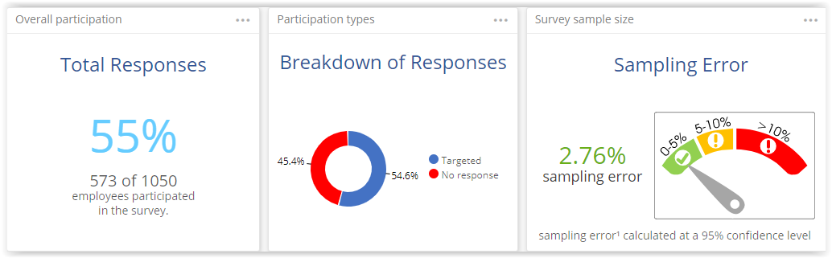

* The **sampling error** for organization overall < 5% is good, meaning that the survey can be viewed at least at organizational level as sufficiently representative of the views and opinions of the rest of the employees

| *#* | *Observations* | *Implications* |
| --- | --- | --- |
| 1 | [Note anything that stands out] | [So what? Describe the implications of what you observed on the organisations if left unchanged] |
| 2 | Etc. |  |

## Survey Participation per Business Unit

Next step will be to take a look at the survey participation rates and sampling errors or the high-level business units (if any).

* **Scroll down** to the next panel where the survey participation per business unit will be summarized.
* Click on the **business unit** with **down arrows** next to them to expand so you can view their sub-units.

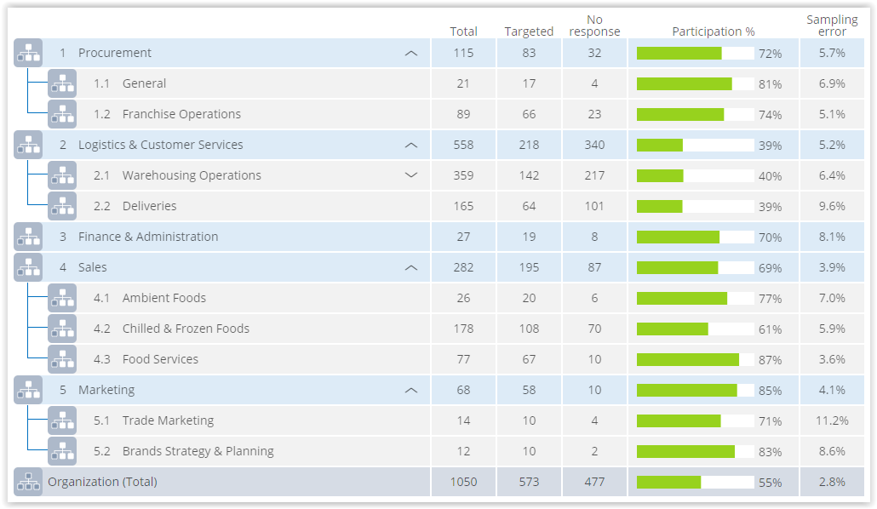

* You can also set a business unit filter to view the survey participation data of only the selected business unit(s) and/or their sub-units.

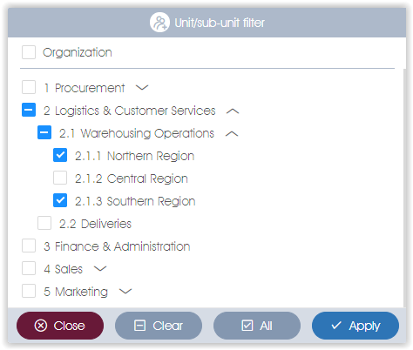

* Note the top-level business with **sampling errors > 10%**, such as 5.1 Trade Marketing in the example above; their survey results should be interpreted with caution etc.

| *#* | *Observations* | *Implications* |
| --- | --- | --- |
| 1 | [Note anything that stands out] | [So what? Describe the implications of what you observed on the organisations if left unchanged] |
| 2 | Etc. |  |

## Survey Participation per Demographic

Let us now take a look at the survey participation numbers per demographic category. This is important because why blah blah blah.

* Scroll down further to the **Survey Participation per Demographic** section. The number of respondents for each of the demographic categories as defined during the survey setup stages, will be displayed.

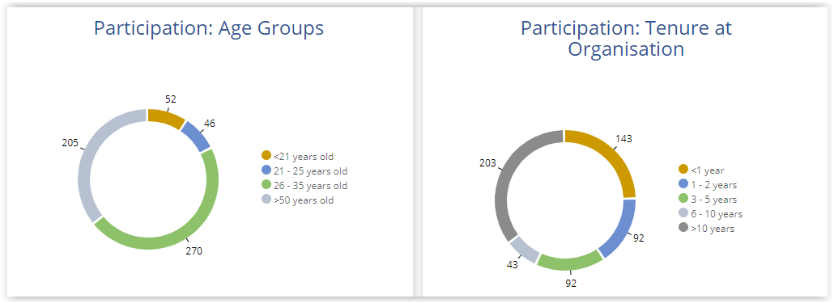

* Check whether the **numbers make sense** and whether they are in line with the client organization’s demographic composition as captured during the survey setup stages – errors do sometimes sneak in when the organizational structure is captured or employee lists imported.
* In case of surveys that made use of **public survey links** where employees were asked to provide their demographic details, make double sure that the demographic breakdown makes sense – employees sometimes select the wrong demographic parameters either due to a misunderstand or sometimes deliberately.

| *#* | *Observations* | *Implications* |
| --- | --- | --- |
| 1 | [Note anything that stands out] | [So what? Describe the implications of what you observed on the organisations if left unchanged] |
| 2 | Etc. |  |

# Step 2: Levels of Engagement (Outcomes)

The purpose of the section is to first determine whether engagement is a problem or not, and if so, where it is a problem (business units), before focusing in the next section on fixing it (by drilling down on the Drivers and business units)

## Set a Business Unit Filter to view Business Unit Survey Results

To view and analyse the survey results of one or more business units (e.g. Division), set a business unit filter to selectively display the survey results of selected business units.



## Review the overall Engagement Levels

* Navigate to the **Summary** page



* Check out the **High-level summary** panel (boat):

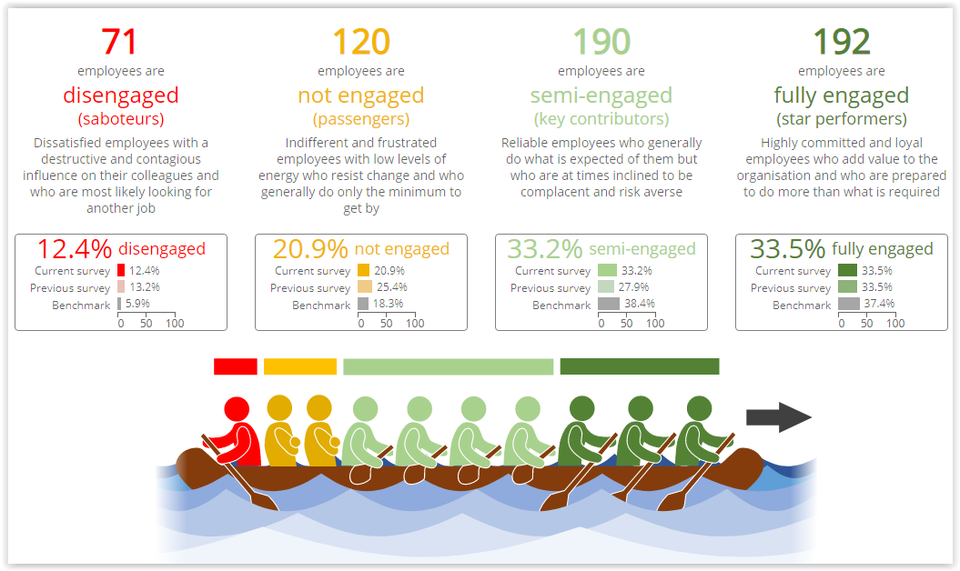

* Review overall engagement levels, compare against benchmark & previous survey, note any statistically significant deviations
* Pay particular attention to Disengaged % - anything approaching 10% or more could point to a problem

| *#* | *Observations* | *Implications* |
| --- | --- | --- |
| 1 | [Note anything that stands out] | [So what? Describe the implications of what you observed on the organisations if left unchanged] |
| 2 | Etc. |  |

* Scroll down to **Indicator distribution** panel:

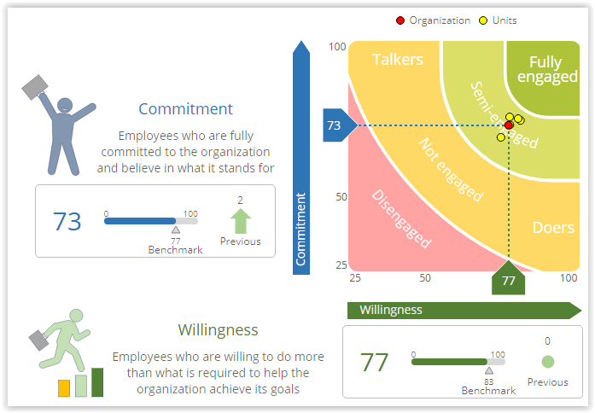

* Check whether Commitment and Willingness more or less balanced
* Check distribution/spread of business units on scatter graph, check for outliers
* Check for any significant increases/decreases from previous surveys or from benchmark
* Check whether retention is a problem

| *#* | *Observations* | *Implications* |
| --- | --- | --- |
| 1 | [Note anything that stands out] | [So what? Describe the implications of what you observed on the organisations if left unchanged] |
| 2 | Etc. |  |

* Scroll down to **Indicator breakdown** panel:

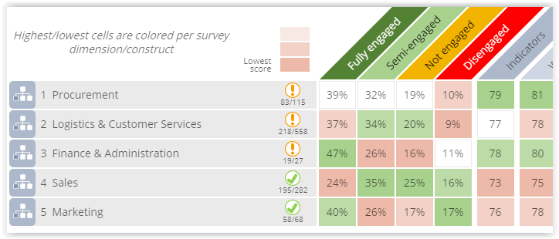

* Check top/bottom business units (look at the top/bottom indicator scores, not at the engagement levels); ignore business units with sampling errors >10% (note top/bottom business units – we are going to come back to them later on)
* Check for business units with high/large Disengaged % - that could be a problem

| *#* | *Observations* | *Implications* |
| --- | --- | --- |
| 1 | [Note anything that stands out] | [So what? Describe the implications of what you observed on the organisations if left unchanged] |
| 2 | Etc. |  |

* Scroll down to the **Engagement Indicator Scores per Demographic** panels:  
    
  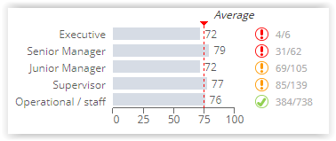
* Check to see if there are significant deviations in engagement indicator scores for any of the demographic categories (e.g. Males scored 67, Females scored 78)
* Check whether management is more/less engaged than the rank-n-file (should be higher)
* Check for Gender or Generational issues

| *#* | *Observations* | *Implications* |
| --- | --- | --- |
| 1 | [Note anything that stands out] | [So what? Describe the implications of what you observed on the organisations if left unchanged] |
| 2 | Etc. |  |

## Review the Engagement Indicator Survey Questions

* Navigate to the **Survey Questions** page



* Expand the Willingness questions: check if any questions outliers with respect to:
* Scores if compared to the average score for the construct – could point to problem area, e.g. in example below questions 3 & 4 are problematic
* Check for any of the questions that increased or decreased significantly from the previous survey
* Deviations from benchmark

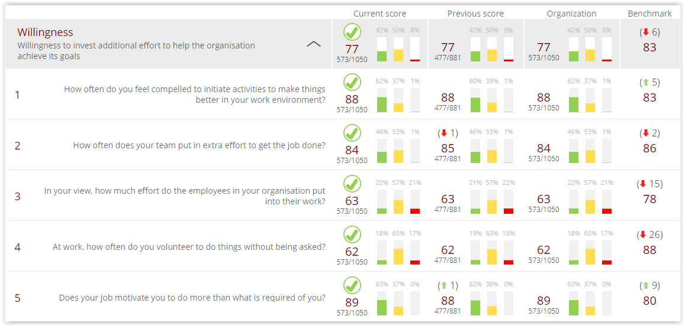

* Do the same for the Commitment indicator

| *#* | *Observations* | *Implications* |
| --- | --- | --- |
| 1 | [Note anything that stands out] | [So what? Describe the implications of what you observed on the organisations if left unchanged] |
| 2 | Etc. |  |

# Step 3: Drivers of Engagement

We now have a good idea of how engaged the organisation and high-level business units are and where should focus to drill down. Now time to take a look at the Drivers of engagement, i.e. issues that impact engagement and that need to be addressed.

## Set a Business Unit Filter to view Business Unit Survey Results

To view and analyse the survey results of one or more business units (e.g. Division), set a business unit filter to selectively display the survey results of selected business units.



## Review the Average Driver Scores

* Navigate back to the **Summary** page



* Scroll down to the **Driver summary** panel:
* Check/note the two top scoring drivers (green bars) – indicate aspects done really well, should keep it up
* Check/not the two bottom scoring drivers (red bars) – highlight potential problem areas that will have to be addressed

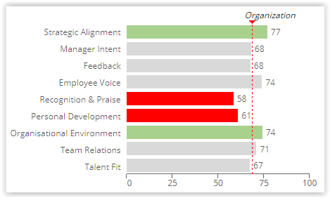

| *#* | *Observations* | *Implications* |
| --- | --- | --- |
| 1 | [Note anything that stands out] | [So what? Describe the implications of what you observed on the organisations if left unchanged] |
| 2 | Etc. |  |

* Scroll down to the **Driver Scores** panel: check for significant deviation from benchmark and/or previous survey

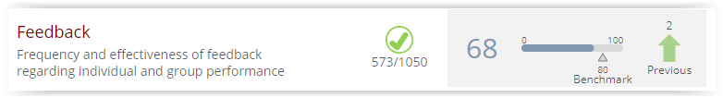

| *#* | *Observations* | *Implications* |
| --- | --- | --- |
| 1 | [Note anything that stands out] | [So what? Describe the implications of what you observed on the organisations if left unchanged] |
| 2 | Etc. |  |

* Scroll down to the **Top/bottom scoring survey** **questions** panel: check the top and bottom questions for outliers and anything that stands out; bottom scoring Driver questions are usually a good indicator of potential problem areas that need urgent attention

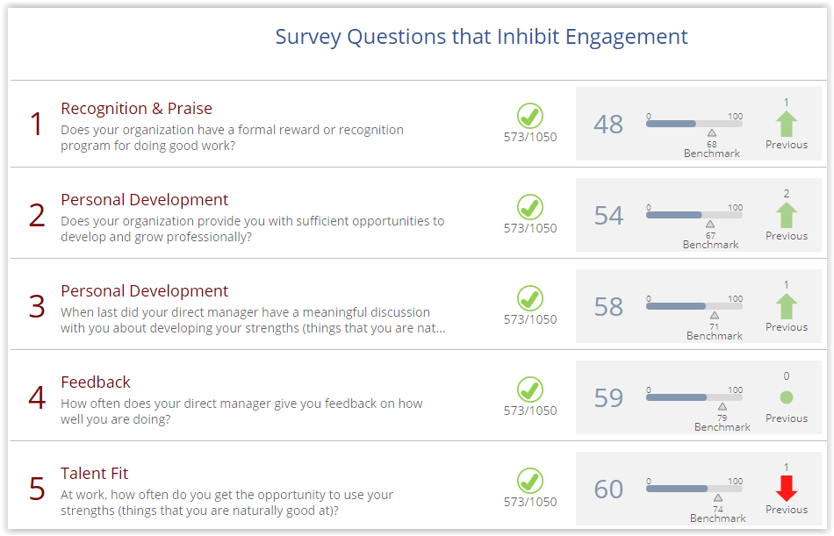

| *#* | *Observations* | *Implications* |
| --- | --- | --- |
| 1 | [Note anything that stands out] | [So what? Describe the implications of what you observed on the organisations if left unchanged] |
| 2 | Etc. |  |

## Review the Driver Survey Questions

* Navigate to the **Survey Questions** page



* Expand the two top scoring drivers (Strategic Alignment and Organizational Environment in this case), and take note of any questions that are significantly higher than the average for the construct, or that show a significant increase from the previous survey – indication of things that are done well and that works
* Expand the two bottom scoring drivers (Recognition & Praise and Personal Development in this case), and take note of any questions that are significantly lower than the average for the construct, or that show a significant decrease from the previous survey

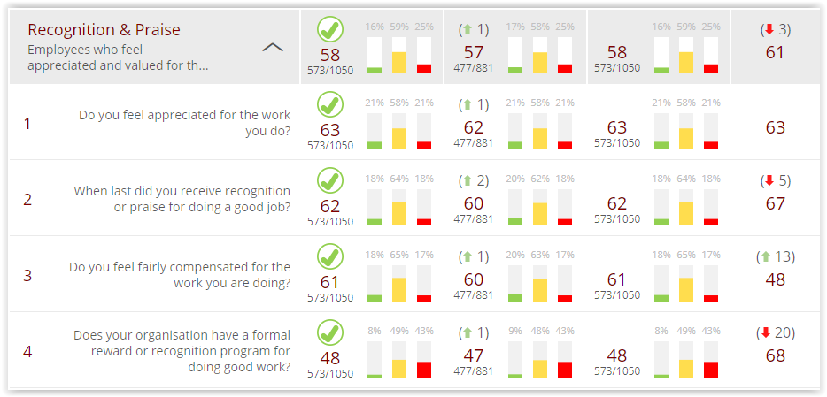

| *#* | *Observations* | *Implications* |
| --- | --- | --- |
| 1 | [Note anything that stands out] | [So what? Describe the implications of what you observed on the organisations if left unchanged] |
| 2 | Etc. |  |

# Step 4: Engagement per Business Unit

OK, next step is to get a better understanding of what is happening with the business units

## Review Business Unit Results

* Navigate to the **Heatmap** page



* Set a business unit filter to view the survey results of only the selected business unit(s)
* Click on the **Maximise panel** arrow at the top/right of the heatmap to expand/maximise the heatmap for a better view of the data

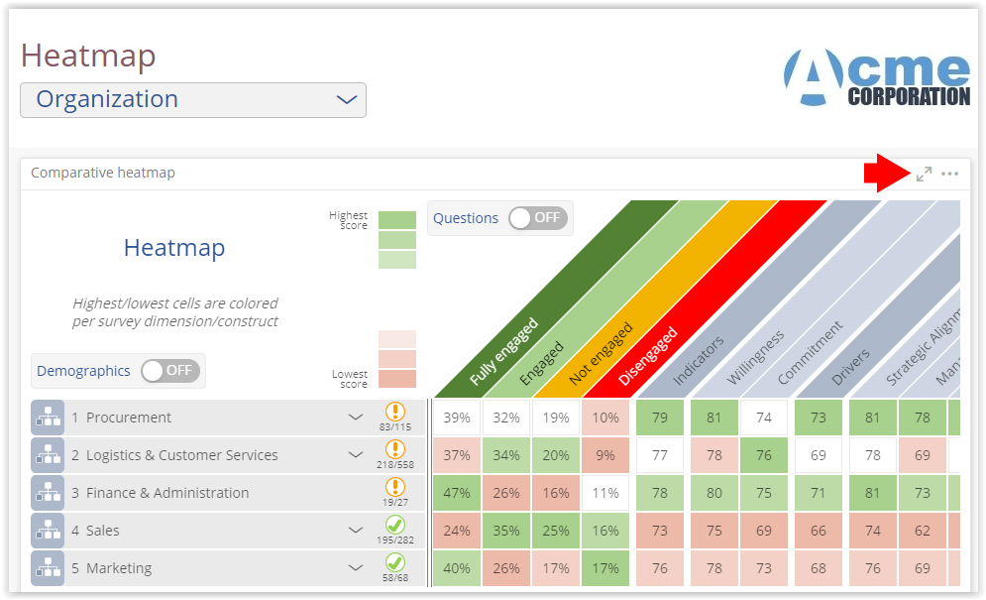

* Expand the 1ste level business units and identify the business units with the highest and lowest Indicator scores and with a sampling error < 10% (green or orange icons)
* See if any outliers or patterns with respect to driver scores of the lowest scoring business unit, e.g. in example below, the lowest-scoring 4.3 Food Services had exceptionally low scores for Manager Intent driver but high scores for e.g. Team Relations, indicating management behaviour may be the main problem

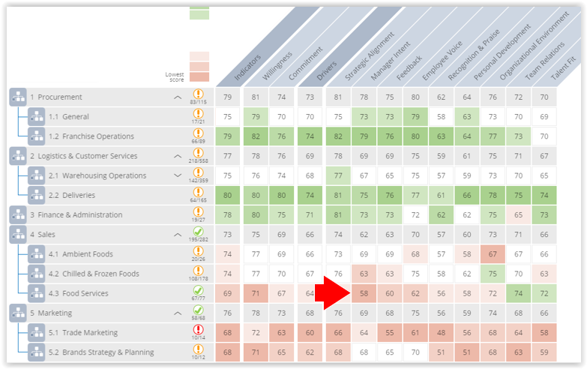

| *#* | *Observations* | *Implications* |
| --- | --- | --- |
| 1 | [Note anything that stands out] | [So what? Describe the implications of what you observed on the organisations if left unchanged] |
| 2 | Etc. |  |

## Comparing Top and Bottom Scoring Business Units

* Navigate to the **Comparisons** page



* Set a filter for the 1st column for the Top scoring business unit (2.2 Deliveries), and the 2nd column for the bottom scoring business unit (4.3 Food Services)

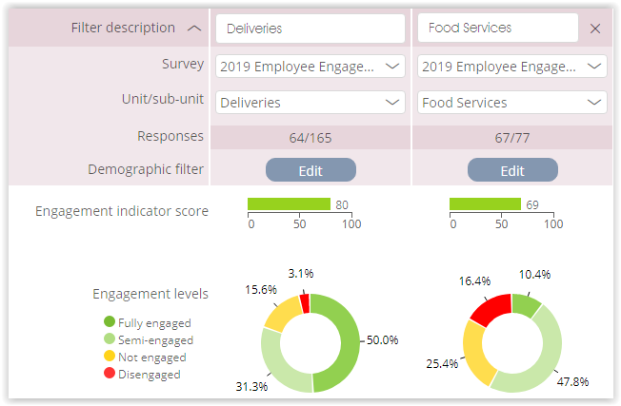

| *#* | *Observations* | *Implications* |
| --- | --- | --- |
| 1 | [Note anything that stands out] | [So what? Describe the implications of what you observed on the organisations if left unchanged] |
| 2 | Etc. |  |

* Expand the Driver constructs, and check all the survey questions for significant deviations or discrepancies, e.g. huge gap re questions 3 and 4 of Manager Intent driver

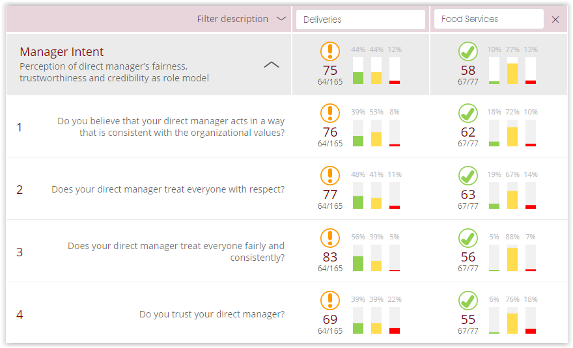

| *#* | *Observations* | *Implications* |
| --- | --- | --- |
| 1 | [Note anything that stands out] | [So what? Describe the implications of what you observed on the organisations if left unchanged] |
| 2 | Etc. |  |

## Reviewing the Demographics of the Bottom Scoring Business Unit

* Navigate back to the **Summary** page



* Set a Business Unit filter by selecting only the lowest scoring business unit (Food Services)

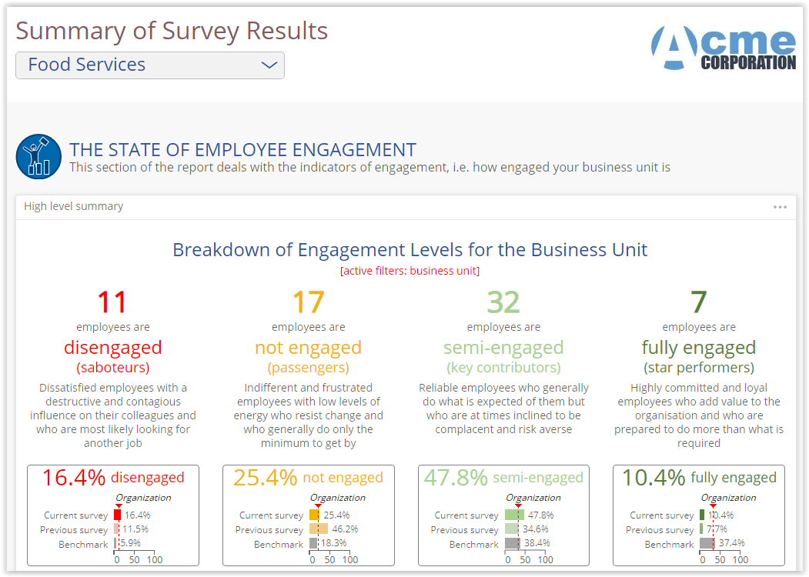

* Take a critical look at the Indicator and Driver scores by following the process as outlined in Step 2: Levels of Engagement (Outcomes) and Step 3: Drivers of Engagement – look for any significant deviations or outliers, e.g.
* Lowest scoring Drivers Manager Intent and Recognition & Praise point to leadership problems

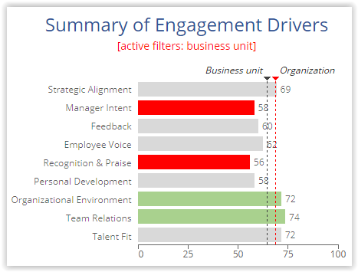

* Exacerbated by lowest scoring questions, with trust in manager and roll model clearly a major problem

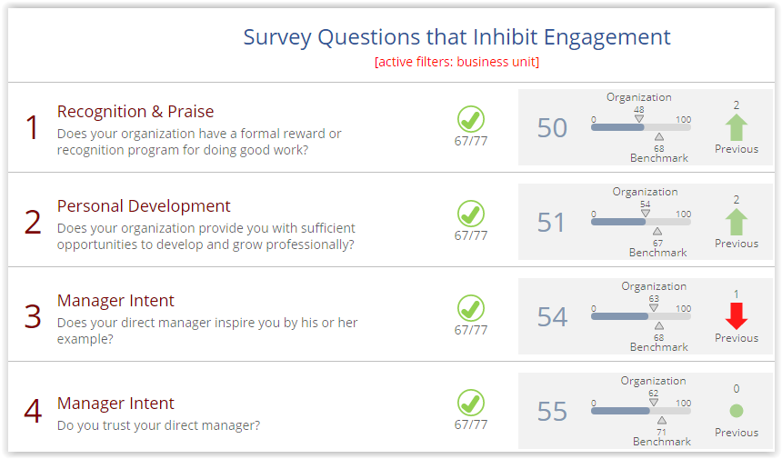

* Demographics, with Senior Manager much less engaged than operational staff

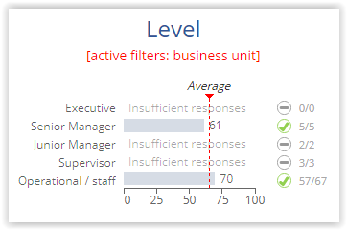

| *#* | *Observations* | *Implications* |
| --- | --- | --- |
| 1 | [Note anything that stands out] | [So what? Describe the implications of what you observed on the organisations if left unchanged] |
| 2 | Etc. |  |

# Step 5: Summary of Observations

You have now taken a critical and analytical look at the survey results, at least at organizational level, and made notes of all outliers, trends, and discernible patterns. Now have sufficient data to form an opinion of what to focus on.

This step will help you to derive main themes that should be focused on by grouping, sorting and synthesizing deductions and notes:

* Collate all notes, Observations and particularly the Implications resulting from previous steps 2 – 4.
* Sort and group them into related topics or themes, e.g. leadership (direct manager’s relationship with team), work environment (engagement-friendly and conducive organisational environment, including policies, processes etc.), personal development
* Review each of the topics or themes and:
* Summarise the issues as highlighted by the survey for the theme
* Articulate what the impact or implications will be if the issues as highlighted in the previous point are not addressed

| *#* | *Themes based on Observations & Implications* | *Recommended Interventions* |
| --- | --- | --- |
| 1 | [Summary of related observations and implications per theme] | [What now? Describe potential interventions to address the issue] |
| 2 | Etc. |  |

# Step 6: Recommendations

Review the topics or themes as derived and summarised in Step 5 and determine for each:

* Possible/suggested remedy or intervention(s) that can be taken in mitigation
* Suggested actions that can be undertaken for each intervention
* Whether the remedy or action qualify as a quick win or a more deliberate and intentional intervention that must be phased in over time

| *#* | *Interventions* | *Actions* |
| --- | --- | --- |
| 1 | [Summary of interventions] | [How? Describe potential actions as part of the intervention] |
| 2 | Etc. |  |